

**The Economic Outlook**

Speech given by

Charlie Bean, Deputy Governor for Monetary Policy, Bank of England

To the Northern Ireland Chamber of Commerce, Belfast Harbour Office, Northern Ireland 19 May 2011

Good afternoon! It is a great pleasure to be back again in Belfast. I am particularly pleased to be addressing you in this historic venue, whose grandeur bears witness to Belfast's long history as a key hub for international trade. That is symbolised in the stained glass windows on the ground floor, which show Neptune, the god of the sea, flanked by images representing the industries synonymous with Victorian Belfast: Navigation; Spinning; Weaving; and Engineering. The local economy has changed considerably since those days. And change will be a theme that runs through my talk today.

It is now 18 months since the economy began to recover from the worst fall in output in the post-war period. Since its trough in 2009 Q3, estimated GDP has risen 2½%, leaving it some 4% below its peak prior to the financial crisis. But towards the end of last year the pace of recovery appears to have slackened. Excluding the effects of the snow, which the ONS say reduced output by about ½ percentage point in the fourth quarter, activity was reported to have been broadly flat across the final quarter of last year and the first quarter of this one; see Chart 1. There is some doubt about this, not least because the official series for construction output has been highly volatile over the past year and looks surprisingly weak in the light of the commentary of the trade associations. But even if we leave out the volatile construction and extraction sectors by focussing just on manufacturing and services, we are still left with a picture of flattish underlying activity through the end of last year and only modest quarterly growth of just ½% at the beginning of 2011.

It may be that later editions of the data may clarify some of this uncertainty, but some1 other indicators, such as measures of consumer and business confidence and the reports from our Agents around the country, also point to a slackening in the underlying rate of expansion around the turn of the year. The crucial question is whether this just represents a temporary “soft patch” of the sort often seen during the early stages of economic recoveries, or whether it is instead the harbinger of a prolonged period of slow growth. To answer this, we need to look at the forces driving the various elements of demand.

For some while even before the financial crisis broke in August 2007, the MPC had drawn attention to the need for the composition of demand in the economy to rebalance away from private and public consumption towards investment and net exports. And associated with such a re-balancing, one would expect to see some shift in the structure of production away from sectors focussed on serving domestic needs towards those producing internationally tradable goods and services. The re-balancing should be facilitated by the depreciation of sterling

– down around a quarter since the middle of 2007 – but is still at an early stage.

Household spending stagnated over 2010 and remains around 4% below its pre-recession level (Chart 2). The sluggishness of consumer spending should hardly be a surprise. Real post-tax labour incomes have been squeezed by a mix of low pay growth and elevated inflation on the back of higher VAT, energy and import prices. In addition, heightened uncertainty probably led some households to increase their savings or pare back their

1. Though not all: recent employment data, for instance, have been surprisingly robust.

debts. The most recent survey of retailers by the British Retail Consortium suggested that the fine Easter weather and the royal nuptials may have brought a welcome fillip to the High Street, but with the squeeze on real pay likely to continue through this year, it seems likely that consumer spending will remain subdued through this year at least. Public spending will also provide little impetus to overall activity, given the necessary fiscal consolidation that is now under way. That, of course, is a particular issue here in Northern Ireland.

So, the prospect for overall growth depends heavily on business spending and external demand. In contrast to the stagnant consumer, business spending on inventory accumulation and fixed capital together contributed 2½ percentage points to GDP growth last year. The contribution from stockbuilding cannot be expected to persist and indeed has already waned somewhat. As far as capital spending goes, on the one hand, there

seems little rationale for businesses to expand capacity while activity is weak and there is still a margin of spare capacity. On the other hand, business investment is still about 20% lower than its pre-crisis peak (Chart 3).

Some of that shortfall reflects replacement investment postponed during the recession, which is likely to be

re-instated at some juncture. Moreover, even though overall demand may remain depressed, the rebalancing in activity towards the internationally tradable sectors of the economy will probably necessitate some expansion in capacity in those sectors, while achieving cost savings and efficiency gains also often requires investment.

Finally, many large companies are presently cash-rich and can access the capital markets. So a shortage of finance should not prevent them increasing their investment spend, though some smaller businesses relying on bank credit may have more trouble. But, overall, it seems reasonable to expect further recovery in business investment.

Given the past substantial depreciation of sterling and the associated improvement in the competitive position of UK suppliers, the performance of net exports has so far been somewhat disappointing. That is less to do with exports, which grew by more than 5% in 2010, reflecting both strong global growth and improved competitiveness. Rather the let down has been on the import side, where there has been less substitution of domestically supplied goods and services for imports than past experience would have led one to expect. It is possible that increased specialisation means that demand is less responsive to price than it used to be.

Alternatively, heightened uncertainty and the absence of UK suppliers for some sorts of goods and services may mean that it takes longer for import penetration to respond to the enhanced profit opportunities. In any case, the MPC still expects net exports to contribute substantially to the overall growth in demand over the next few years as the necessary rebalancing gradually takes place. The most recent trade figures indicate that net exports of goods boosted GDP by around 1¼ percentage points in the first quarter2, and suggest that we may at last be starting to see a more significant contribution to growth.

1. Imports of aircraft were temporarily high in 2010 Q4 reflecting the forthcoming change in VAT treatment, but the data were still encouraging even after allowing for the resulting distortion to import growth in 2011 Q1.

Chart 4 shows the MPC’s current assessment of the outlook for four-quarter GDP growth, as published last week in the Bank’s latest *Inflation Report* and assuming that Bank Rate follows the gently rising path implied by market interest rates. The single most likely path lies within the deepest green band. The near-term path is somewhat choppy, reflecting the impact of factors such as the extra bank holiday associated with the royal wedding. But the underlying picture is one of growth gradually picking up to around its historical average rate, reflecting continued recovery in investment and a higher contribution from net exports and, on the back of that, some modest strengthening in consumer spending as we go through next year.

One should not, though, put too much weight on any single path, as the coloured fan in Chart 4, which covers nine out of ten of the possibilities as we see them, is pretty wide. That serves to emphasise the high degree of uncertainty at the current juncture. Those uncertainties include not only the spending of households and businesses here in the United Kingdom, but also the evolution of demand abroad. In particular, while the euro area overall has exhibited decent growth in recent quarters, the countries of the periphery are struggling with a mixture of fiscal, banking and competitiveness problems. There is a risk that this could lead to renewed banking sector turbulence and a hit to confidence more generally, with adverse consequences for us.

Even though our central projection has growth returning to around its historical average rate, that would still leave the *level* of activity well below a continuation of its pre-crisis trajectory (Chart 5). That makes it unlike normal downturns, in which the economy usually experiences a period of above-average output growth during the recovery period, thus making up much of the lost ground.

The tendency for economies to suffer substantial persistent losses relative to a continuation of their pre-crisis trajectory is a common feature of downturns after banking crises. That is illustrated in Chart 6, which shows the spread of outcomes for the shortfall of output relative to a continuation of its pre-crisis trajectory across 88 past banking crises in different countries3; the blue swathe covers the central 50% of cases, while the grey swathes take in the central 80% of cases. There is a considerable diversity of experience, but the average outcome – given by the purple line in the middle of the swathe – shows a persistent output shortfall of about 10%, even seven years after start of the crisis. In other words, the typical banking crisis results in a substantial persistent depression in activity relative to what might otherwise have taken place. The red line shows the central path for the level of output, relative to a continuation of its pre-crisis trend, from our most recent projections (the dash denotes the forecast period up to and including 2013). As you can see, that path lies quite close to the average experience from this sample of past banking crises.

There are a number of reasons why output losses after banking crises have tended to be much more persistent than after normal economic downturns. First, banks and highly-indebted households and businesses need to get their balance sheets back in order, typically resulting in a period of low credit growth and high savings.

1. Taken from the IMF’s World Economic Outlook, October 2009.

Second, the injection of public funds into stricken banking systems, coupled with a loss of tax revenues in the downturn, results in a deteriorating fiscal position, which subsequently needs correction. Third, such crises often also result in some long-lasting impairment of the economy's supply capacity.

We can see the first two mechanisms at work in the UK economy. But it is not so easy to see what is happening to the economy's supply capacity and therefore also to the available margin of spare capacity, which is an important determinant of domestic inflationary pressures. Certainly there is some spare capacity in the labour market, where the unemployment rate is around 3 percentage points above its pre-crisis level. But the margin of spare capacity within firms is less clear.

In recessions, employers normally hang on to essential or hard-to-replace employees. As a consequence, the growth in output per hour worked typically slows, while unused capacity is simultaneously created. Productivity then accelerates sharply in the recovery phase, as that labour is brought back into use and the margin of unused capacity diminishes. But while productivity growth slowed sharply in both services and manufacturing during the downturn, only the latter has subsequently picked up (Chart 7). Moreover, since the trough, employment and total hours worked have risen by around 1½%, not much less than the 2½% rise in output. This suggests *underlying* productivity growth, and with it the rate of growth of the economy’s supply capacity, may have fallen back during the recession. And that is corroborated by business surveys, which suggest that manufacturers are, on average, back to pre-crisis utilisation rates, while the margin of spare capacity has also closed significantly in services firms (see Chart 8).

It is, though, unclear why underlying productivity growth should have been quite so weak. To be sure, the collapse in business investment has resulted in a somewhat lower rate of growth of the capital stock, but estimates suggest that can only account for a modest slowing in underlying productivity growth. And while some businesses will certainly have been forced to reduce the scale of their operations or close because of lack of access to credit, corporate bankruptcies have remained at relatively low levels. Overall, there are few objective indicators to suggest a major hit to capacity growth from the crisis and subsequent recession. It is possible that the true fall in output during the recession has been overstated in the official statistics4, but the extent of the mismeasurement would have to be very large to reconcile all the facts. It is all somewhat puzzling!

Even if the margin of spare capacity in businesses is no longer all that great, the elevated level of unemployment should have put downward pressure on inflation. And, indeed, wage growth has been, and remains, subdued (Chart 9). But other factors have conspired to push inflation well above the MPC's 2% target.

1. For instance, the value added by the financial sector is conceptually very difficult to define and measure. The ONS are therefore forced to employ a variety of proxy indicators, such as balance sheet information. It is possible that these proxies overstated both the true contribution of the financial sector to GDP growth before the crisis and its subsequent fall.

First, the substantial depreciation of sterling, though helpful to the necessary re-balancing of the UK economy, also simultaneously raised import prices. We initially underestimated how strong this impact would be, but we now think that the rise in import prices as a result of depreciation has added somewhere between 4¼% and 6½% to the level of consumer prices. Second, commodity prices – especially oil prices (Chart 10) – have been on something of a roller-coaster, rising sharply on the back of strong growth in the emerging economies up to mid-2008, then falling back sharply as global activity collapsed at the end of 2008. They have subsequently rebounded, reflecting both the recovery, especially in the emerging economies, and temporary adverse supply factors (bad weather affecting agricultural commodities; unrest in the Middle East and North Africa affecting oil). Finally, the increase in the standard rate of VAT has also boosted inflation.

The blue swathe in Chart 11 shows our estimate of the combined contribution of these three factors, for a range of plausible assumptions, together with the actual inflation rate (the red line). The green swathe is the implied contribution from all other influences on inflation. It is worth noting that the current elevated inflation rate of 4.5% can be largely accounted for by the effects of energy and import prices and VAT: energy prices and VAT are probably each contributing around one percentage point to current inflation, and non-energy import prices around double that.

The twelve-month inflation rate is likely to remain elevated through the remainder of this year, and indeed may rise further in the second half of the year, as utility prices are likely to rise sharply to reflect higher oil and wholesale gas prices. But inflation should fall back as we go into 2012 and factors such as the rise in VAT drop out of the calculation. But the pace and extent to which inflation will drop back will depend on a number of factors. First, there may be further significant movements in commodity prices and in import prices more generally. Second, there may be some resistance to the past erosion in living standards, resulting in a period of faster pay growth. Third, although pay growth has been subdued, the low rate of growth of productivity has nevertheless resulted in a squeeze in profit margins and there may be some attempt to restore these as the economy strengthens. Finally, if the period of elevated inflation leads business and households to expect higher inflation in the future, then it may also lead them to set higher pay and prices.

Chart 12 shows our current assessment of the inflation outlook, also assuming that Bank Rate rises in line with market yields, and with the most likely path lying inside the deepest red band. This shows inflation moving towards the target through next year, though, as I have already indicated, there is considerable uncertainty about the speed at which that will happen. But we judge the chances of inflation being above or below the target by the end of the forecast period to be roughly equal.

In concluding, there are two general points that I want to make regarding the current conjuncture. The first is that the next few years are likely to continue to be rather difficult, especially for households and consumer-facing businesses. The economy is still adjusting to three substantial shocks, all of which conspire to reduce UK living

standards. There is the loss in output associated with the banking crisis, the consequences of which households have hitherto been partially sheltered from by the expansion in the budget deficit. There is the rise in commodity prices relative to the global price of finished goods and services, which means that we have to pay more for the raw materials that we need. And there is the substantial depreciation of sterling, which is a counterpart to the necessary re-balancing of the economy, but which also implies that we have to pay more for our imported goods and services.

The second, and related, point is that while monetary policy cannot ultimately insulate us from the associated hit to our living standards, it can affect the adjustment path. In particular, the MPC’s chosen approach has been to accept a temporary period of above-target inflation, rather than seeking to hold inflation as close to the 2% target as possible at all times. Achieving the latter would have required a markedly higher level of Bank Rate and with it most probably a somewhat higher level for sterling. That would have moderated some of the external inflationary impulses facing us, but would also have depressed activity and pay even more and retarded the requisite re-balancing of the economy. The Committee’s approach has, I believe, been consistent with its mandate from the Chancellor of the Exchequer, which recognises “that the actual inflation rate will on occasions depart from its target as a result of shocks and disturbances” and that “attempts to keep inflation at the inflation target in these circumstances may cause undesirable volatility in output.”

It is almost 100 years to the day since the ill-fated Titanic was launched from Queen’s Island, just across the channel. It may be tempting to see a parallel between the hubris and excessive risk-taking that resulted in its tragic encounter with an iceberg on its maiden voyage, and the hubris and excessive risk-taking that led up to the Great North Atlantic Financial Crisis of 2008. But a more optimistic parallel is provided by rebirth of the old Harland and Wolff shipyard as the Titanic Quarter, the biggest regeneration project in Northern Ireland's history and the largest waterfront redevelopment in Europe. That serves as a reminder of the ever changing nature of the fabric of the economy, as old industries make way for new. And it also serves as a suitable metaphor for the UK economy more generally, as it begins to re-balance in the wake of the deepest downturn in the post-war period.

Thank you!

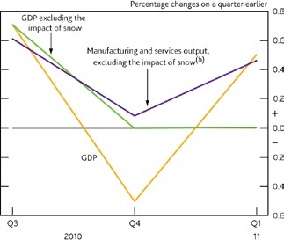

**The Economic Outlook**

Presentation to Northern Ireland Chamber of Commerce, Belfast

Charlie Bean, Deputy Governor Monetary Policy

19 May 2011



**Chart 1: GDP and manufacturing & services output**

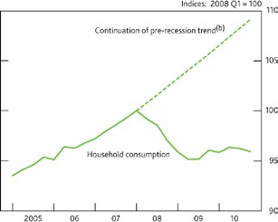

**Chart 2: Household consumption**

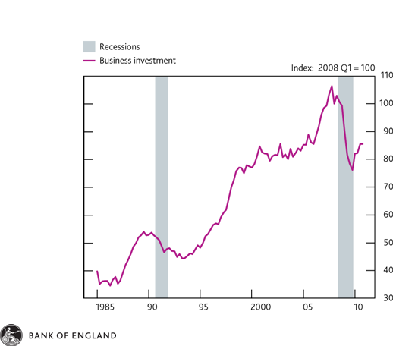

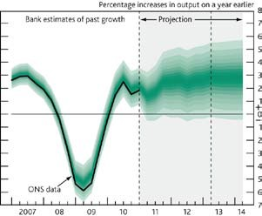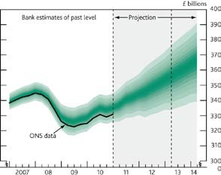



**Chart 4: GDP growth projection**



**Chart 5: GDP projection**



UK 10

0

-10

-20

-30

-40

-50

-1 0 1 2 3 4 5 6 7

Distance in years from the first year of crisis

Percent of pre-crisis trend; mean difference from year t = - 1

20

10th-90th percentile Interquartile range

Estimated mean path

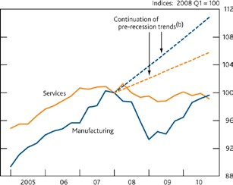

**Chart 6: Output losses after banking crises**



**Chart 7: Labour productivity**

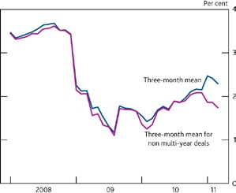

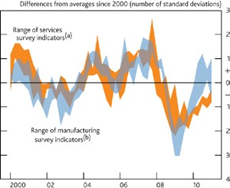

**Chart 8: Survey measures of capacity utilisation**



**Chart 9: Private sector pay settlements**

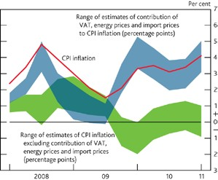

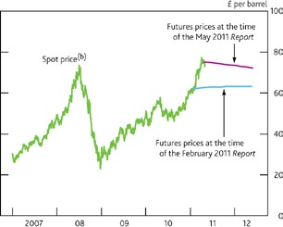

**Chart 10: Sterling oil prices**



**Chart 11: Contribution of VAT, energy & import prices to CPI inflation**

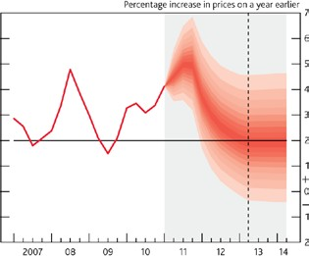



**Chart 12: CPI inflation projection**